**CurneuMedTech Innovations**

TASK:

K-Nearest Neighbour Algorithm- Fruit Classification

DATASET:

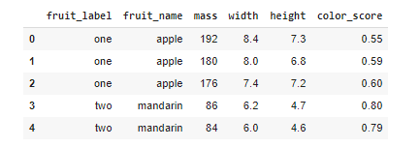

CODE:

import numpy as np

import pandas as pd

import numpy as np

import matplotlib.pyplot as plt

data = pd.read_csv("fruits.csv")

data.head()

one = data[data["fruit_label"] == "one"]

two = data[data["fruit_label"] == "two"]

three = data[data["fruit_label"] == "three"]

four = data[data["fruit_label"] == "four"]

plt.scatter(one.mass,one.width,one.height, color ="r" , label = "one", Alpha = 0.3)

plt.scatter(two.mass,two.width,two.height, color ="g" , label = "two", Alpha = 0.3)

plt.scatter(three.mass,three.width,three.height, color ="b" , label = "three", Alpha = 0.3)

plt.scatter(four.mass,four.width,four.height, color ="y" , label = "four", Alpha = 0.3)

plt.xlabel("mass")

plt.ylabel("width")

plt.legend()

plt.show()

OUTPUT

